Table of Contents

**CHAPTER 1** 4

**1.1 INTRODUCTION** 4

**1.2 PROJECT AIM AND OBJECTIVES** 4

**1.3 USER REQUIREMENTS** 4

**1.4 BACKGROUND OF PROJECT** 5

**1.5 PRODUCT DESCRIPTION** 5

**1.6 PROBLEM STATEMENT** 6

**1.7 PROPOSED SYSTEM OBJECTIVES** 6

**CHAPTER 2** 7

**2.2 METHODOLOGY** 7

**2.2.1 FRONT END** 7

**2.2.2 BACK END** 7

**CHAPTER 3** 8

**3.1 IMPLEMENTATION AND CODING** 8

**3.1.1 Entity Relational Diagram** 8

**3.1.2 Steps in Creating a database with PhpMyAdmin** 9

**3.1.3 Software Interface** 14

**CHAPTER 4** 45

**4.1 CONCLUSION** 45

**REFERENCES** 46

**ACKNOWLEDGMENT**

The end of our academic careers has come. During this period, various experiences have been gained. To do research and development of such software could be considered as well worth as various software development platforms have been used and learned, especially in the field of PHP. Moreover, working on such a development process has allowed us to understand how one can cope with problems in the industry, how could we possibly meet the needs of the people, and that one should be patient and never give up. For teachers gave us this opportunity to work on such development, love patience, support, and trust where they are one of our role models, we would like to give our best regards and respect to teachers and Dr. Kian Jazayeri

**ABSTRACT**

A library management system is system developed to take care of all the library activities. The login page provides the protected accessibility to the system only registered admins and student can access to the system. It offers a feature that allows students to see a list of books issued, as well as their issue and return dates, after logging into their accounts. This system will enter all of the books and members' information into the system database, including book numbers, titles, and author names. It also has a search option to assist students in finding a book by searching through numerous books. After the student find the book in the physical library, the student panel will be use by to find the book in the system through the book page and issue the book. The administrator can perform administrative tasks like adding and deleting books, accepting issues, renewing and returning request books, deleting students, and changing their content. Overall, the goal of this project is to assist students and library staff in maintaining the library in the best possible way while also reducing human labor.

# **CHAPTER 1**

## **1.1 INTRODUCTION**

A library management system is system developed to take care of all the library activities. The major goal of this system is to effectively manage library operations daily.

## **1.2 PROJECT AIM AND OBJECTIVES**

Objectives of Library Management System (LMS)

a) To allow librarians to manage all the library activities in an automatic way.

b) Online book issue, return, and issue renewing.

c) Request pages for a librarian for accepting requests from the student.

d) Student panel space for requesting and returning books, receiving a message from the library, reporting a bug, recommending a book to the library, display and updating his details.

e) A search column to search the availability of the book.

## **1.3 USER REQUIREMENTS**

This library management system has two panels which are **admin panel** and **student panel**, librarians use the admin panel and student use student panel.

The operation of issuing and returning books is paperless when using a library management system. With input boxes and buttons, this system allows for easy data entry. It's also made to ensure that the library's goods are appropriately stored to protect their safety.

The library management system stores in the database all of the books and users' information, with book numbers, book titles, and author names. This system provides a function that allows to search books and student by name and ids.

After the student find the book in the physical library, the student panel will be use by to find the book in the system through the book page and issue the book. The history page allows the student to view his or her prior issued books, the current issued book allows the student to view the current issued book, return it, or renew it once, and the profile allows the student to view and edit his or her information.

Administrator users will be in charge of administrative tasks such as adding and deleting books, accepting issues, renewing and returning book requests, deleting students, and changing their content. A Roll Number and a password must be entered correctly in order to get access to the system. They can use this page to add, delete, or change the book and borrower database.

## **1.4 BACKGROUND OF PROJECT**

A library management system is system developed to take care of all the library activities it is used in the library by librarians to administer the library using a computerized system that allows them to track operations such as book issues, returns, new book additions, new student additions, etc...

This system also includes books and student maintenance modules, which maintain track of the students who use the library as well as a complete description of the books in the library.

This system prevents data loss. A recording module is also included in the Library Management Systems. If the user is an administrator, you can view all of the library transactions that have been saved in the database.

## **1.5 PRODUCT DESCRIPTION**

A library management system is system developed to take care of all the library activities, it is built to assists users in the daily library’s activities. It lowers the likelihood of paperwork-related issues like file loss, file damage, and time waste. It can assist users in more successfully and efficiently managing transactions or records.

## **1.6 PROBLEM STATEMENT**

The following are examples of problems that happened before the use of a computerized system:

1. File loss: Files can be lost due to human error if the computerized system is not applied. There is a chance that records will be lost due to human mistakes.

2. Damaged file: In a non-computerized environment, the file may be lost due to an accident or human error. Furthermore, natural calamities such as floods or fires may cause data loss.

3. Difficulty searching records: When there is no digital system in place, it is always difficult to look for records, especially if there are a lot of them.

4. Takes up a lot of room: If no electronic system is in place, the space required for the physical storage of files and records grows as well.

5. Expensive: Because there is no automated system, the cost of administering the library will rise as more records are added and managed.

## **1.7 PROPOSED SYSTEM OBJECTIVES**

Improvements in control and performance: The system was created to address the library's current flaws and challenges. Users can be added, users can be validated, and the system is bug-free.

Save time: Once the computerized system is in place, fewer people will be needed to maintain the library, lowering overall costs.

Save money: The librarian can search records with just a few mouse clicks and a few search keywords, saving him time.

# **CHAPTER 2**

## **2.2 METHODOLOGY**

These are the programming language used in this project:

### **2.2.1 FRONT END**

The User Interface of a website or a web application is handled through front end development. Front end developers are the ones who designed the website.

Front end is also referred to as "client-side".

HTML, CSS and JavaScript are the front-end languages.

* **HTML (Hypertext Markup Language**): HTML is a markup language used to structure and display elements on the web page such as paragraphs, lists, and tables.
* **CSS (Cascading Style Sheets): CSS** is a styling language used to style HTML tags
* **BOOTSTRAP:** Bootstrap is a CSS framework that contains predefined CSS style
* **JAVASCRIPT:** JavaScript is a language used to add interaction between user and UI, it’s also used for backend development and scripting.

### **2.2.2 BACK END**

The functionality of a website or any software is handled through back-end development which is referred to as ‘server side’. Back-end developers are responsible for this task.

Programming languages, such as php, java and c#, are examples of back-end languages.

This project is developed using PHP, and MYSQL(PHPMYADMIN)

* **SQL:** SQL (Structured Query Language) is a descriptive computer language developed for updating, retrieving, and processing data in table-based databases.
* **PHPMYADMIN:** PhpMyAdmin is software written in PHP and it is used for database Administration on the web
* **PHP:** PHP (Hypertext Preprocessor) is a server-side language.

# **CHAPTER 3**

## **3.1 IMPLEMENTATION AND CODING**

### **3.1.1 Entity Relational Diagram**

What is an ER diagram (ERD) and what does it mean?

ERD is an abbreviation of Entity Relationship Diagram which is a structure of the database architecture. In an ERD, the essential entities within the system scope, as well as their inter-relationships, are displayed using various symbols and connections.

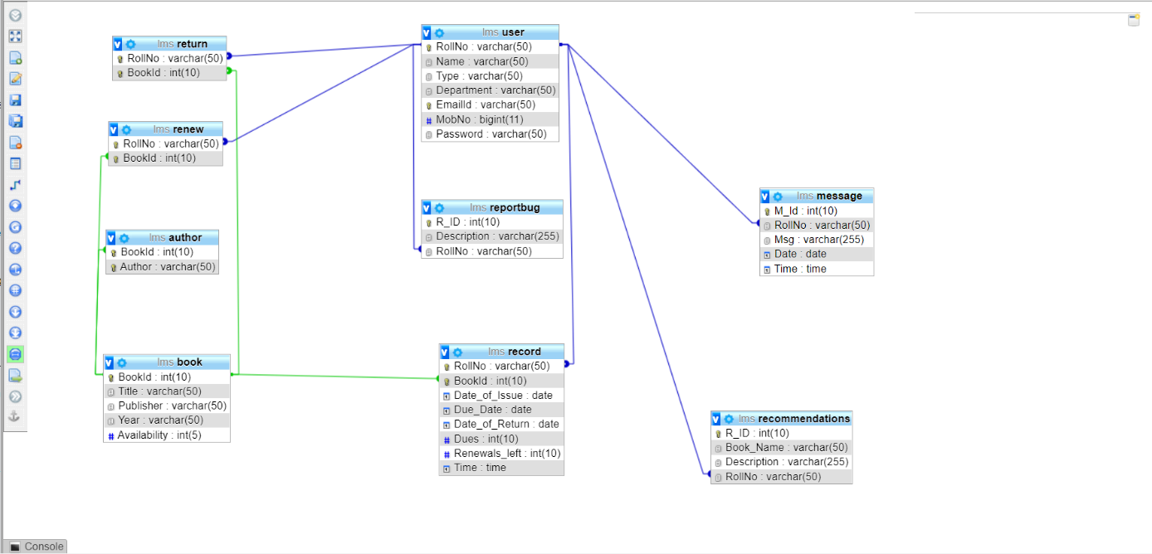

### **3.1.2 Steps in Creating a database with PhpMyAdmin**

1. Download xamp and install it (https://www.apachefriends.org/index.html)

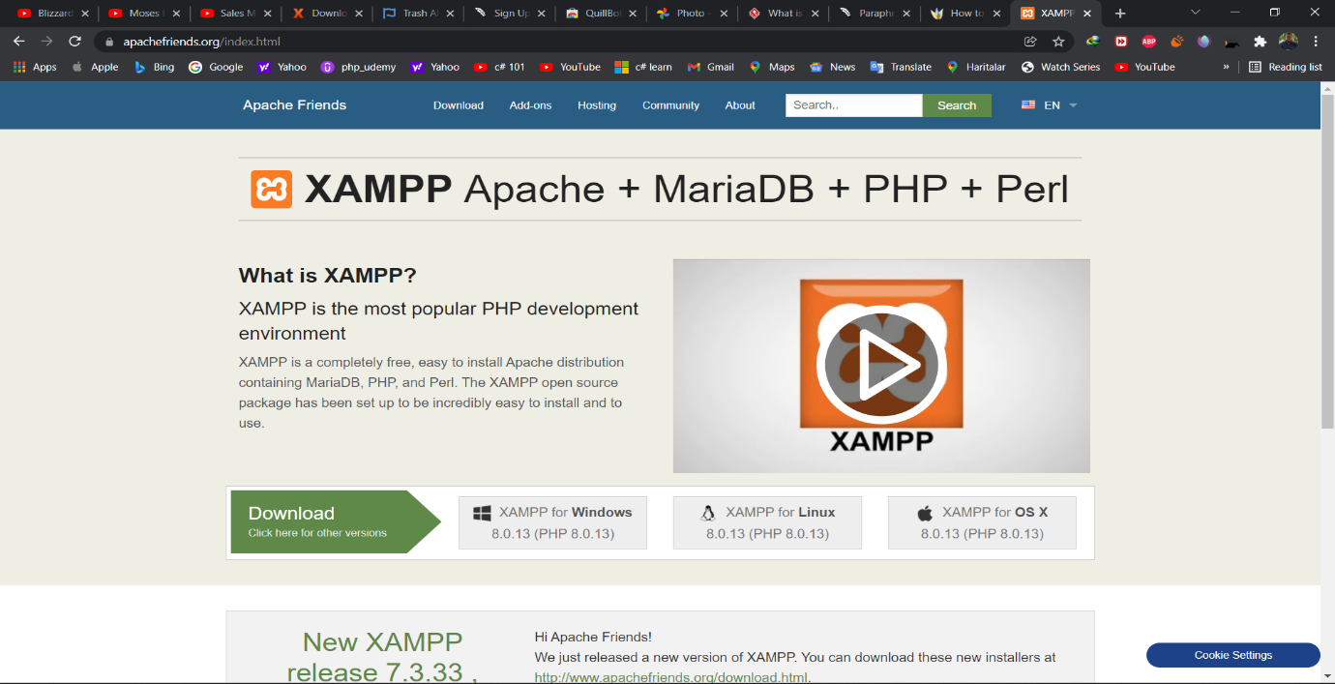

1. Start Apache and MySQL server and click on admin

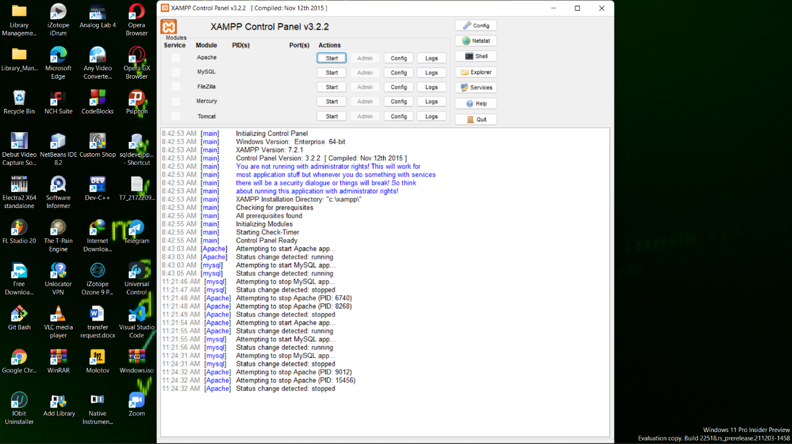

1. Once on the PhpMyAdmin page click on new

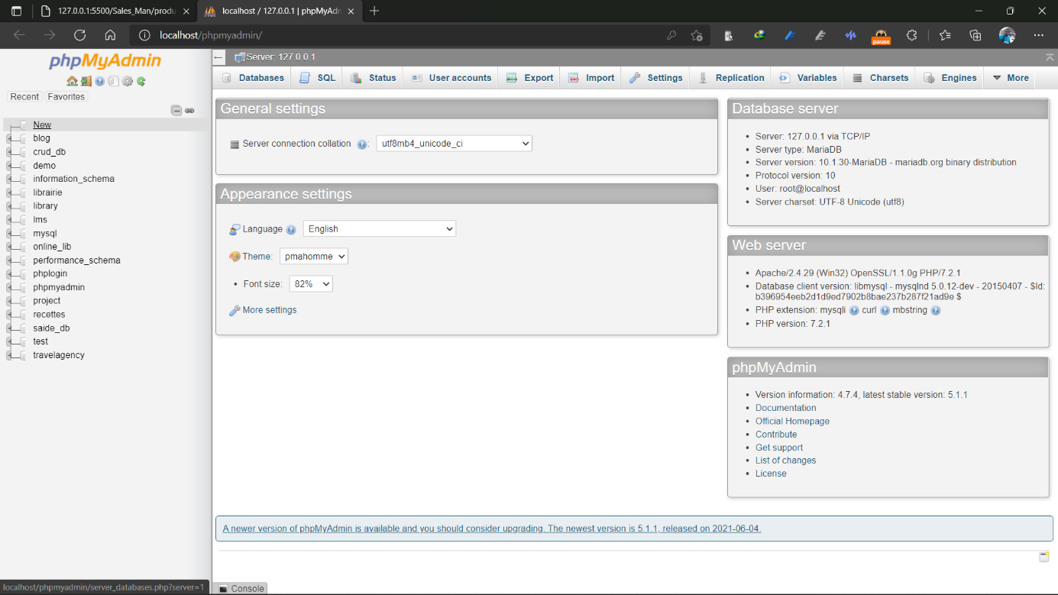

1. Write database name in the input box just below create a database and click on create

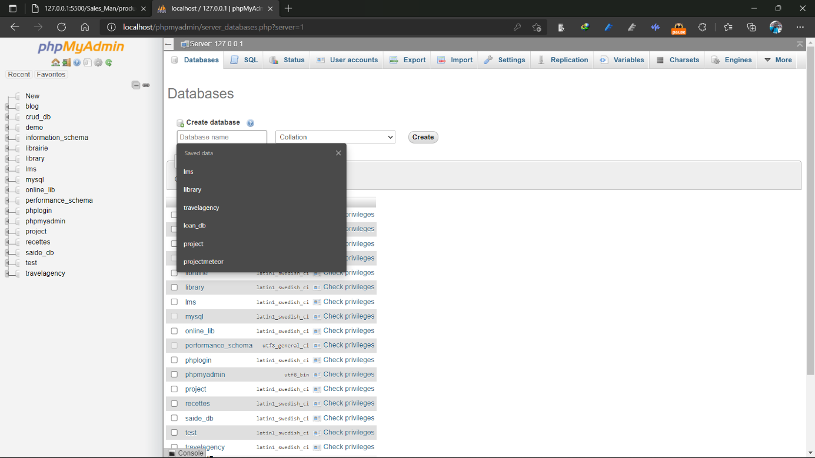

1. After creating the database click on it from the left pan where all databases are listed and click on new then select SQL from the top pan and write your script to create tables and columns(attributes) and click on go.

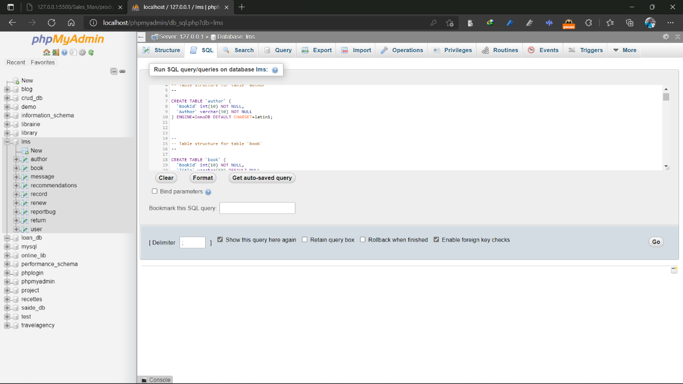

### **3.1.3 Software Interface**

#### **3.1.3.1 Login and sign-up page**

On this page the users(Student or Admin) will enter is Roll Number and Password to login into the Admin panel for Admin and Student Panel for Student and there is a sign-up form for Student only, the student will have to enter the name, email, password 8 characters only, phone number, roll number 6 character, choose the department initial from the combo box list and then click on the sign-up button.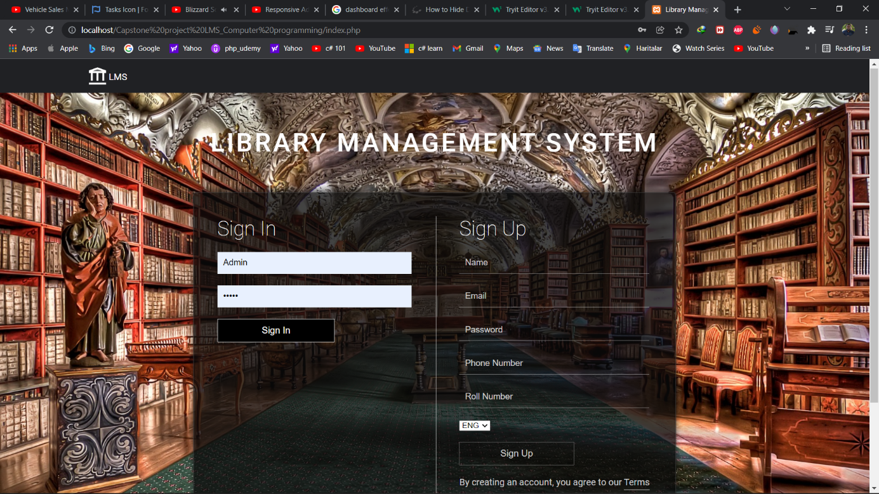

#### **3.1.3.2 ADMIN PANEL**

##### **3.1.3.2.1Dashboard**

On dashboard page Number of book, currently issued book, the book not return and student is displayed

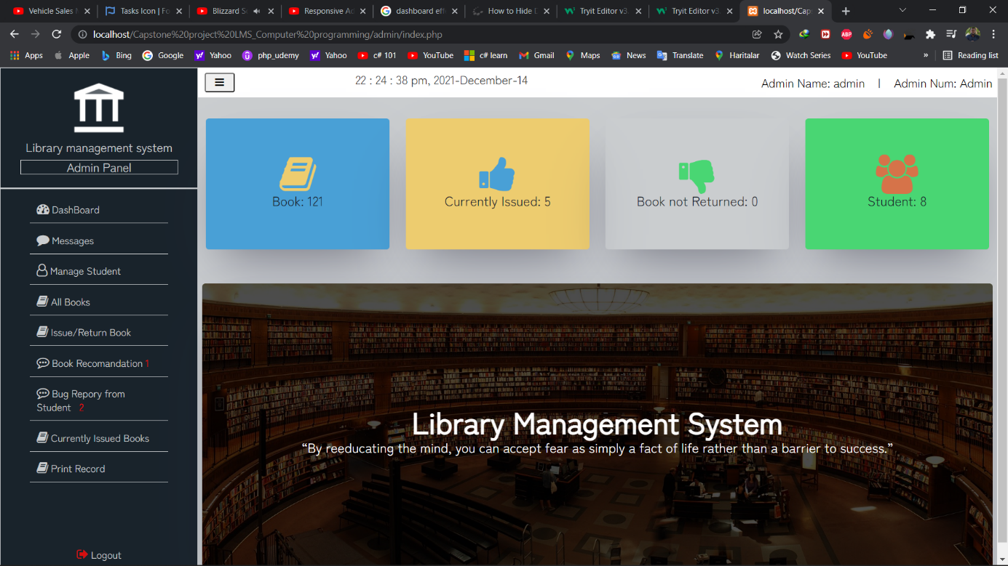

##### **3.1.3.2.2Message**

On the Message page, the admin is sending a message to the student, the admin has to enter the student roll number and write the message then click on the add message button to send the message to the student

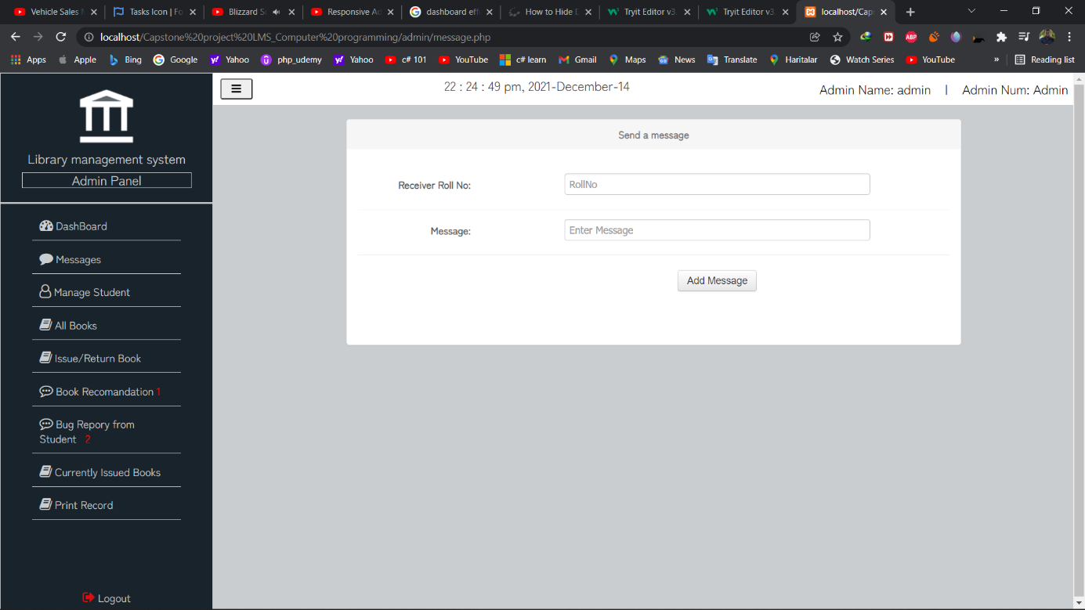

##### **3.1.3.2.3Book**

On the book page, all books are listed and the admin can search for a book, delete, edit and display the details of the book

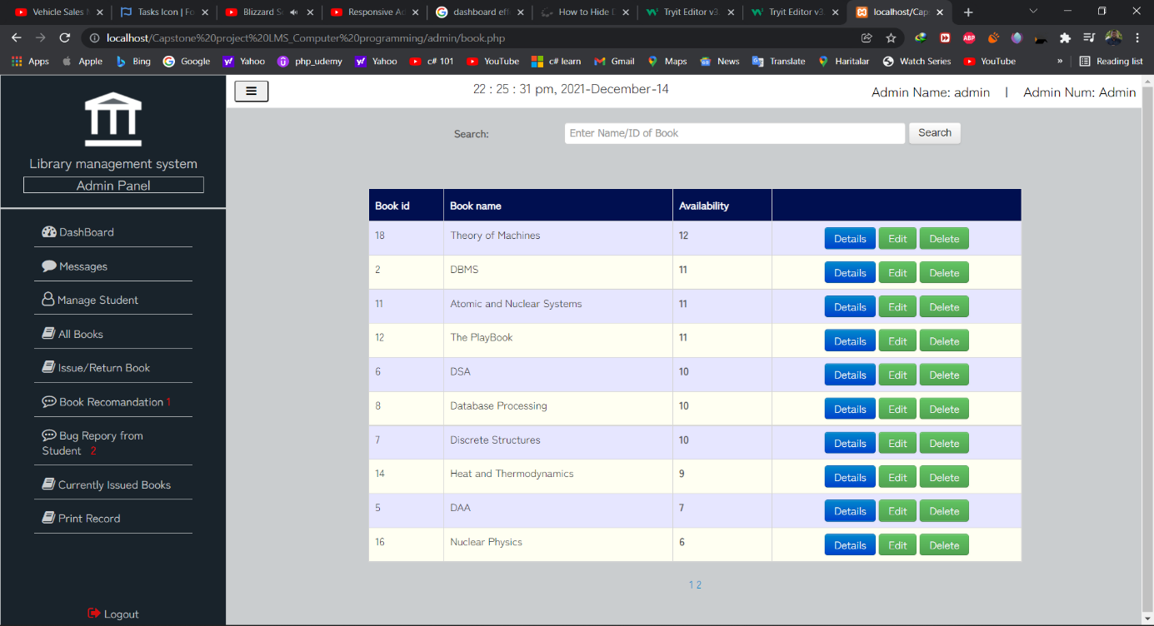

##### **3.1.3.2.4Result of the search book**

This page displays the result of the searched book

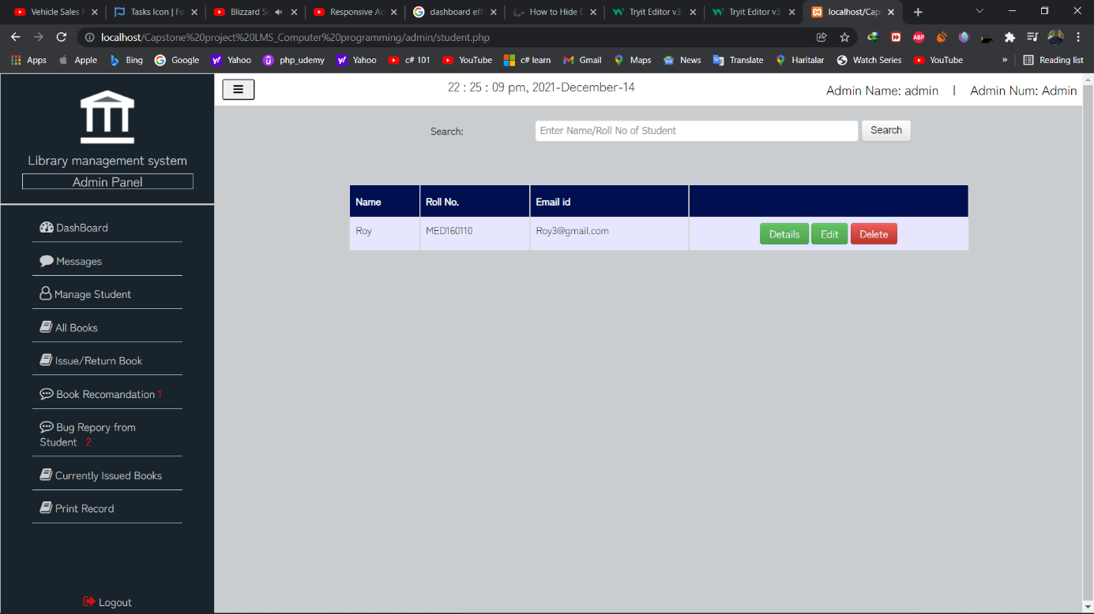

##### **3.1.3.2.5Book details page**

This page displays the book details

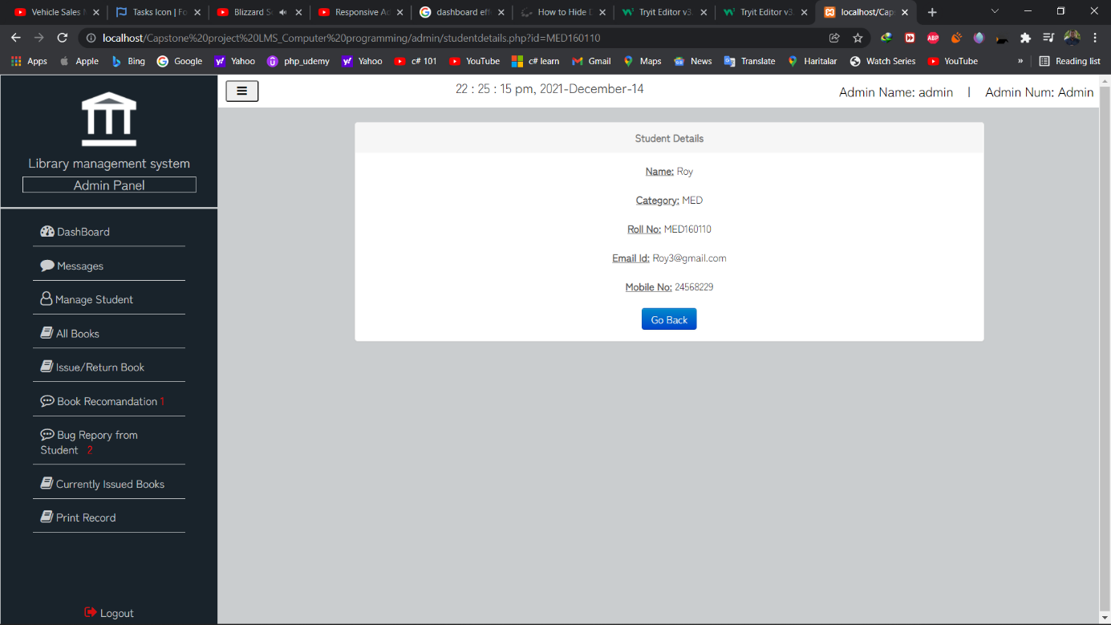

##### **3.1.3.2.6edit book page**

This page provides the functionality to edit the book details

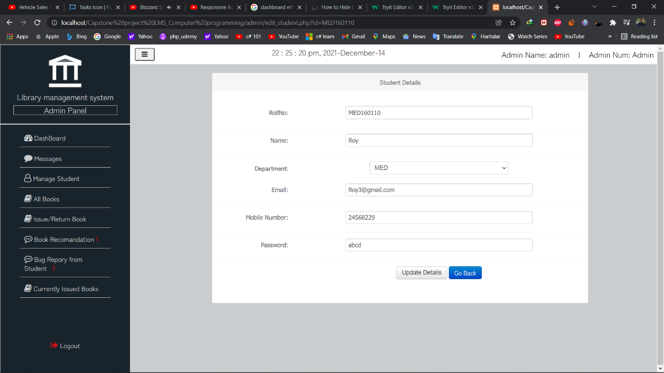

##### **3.1.3.2.7Student**

On the Student page, all Students are listed and the admin can search for Student, delete, edit and just see the details of the book

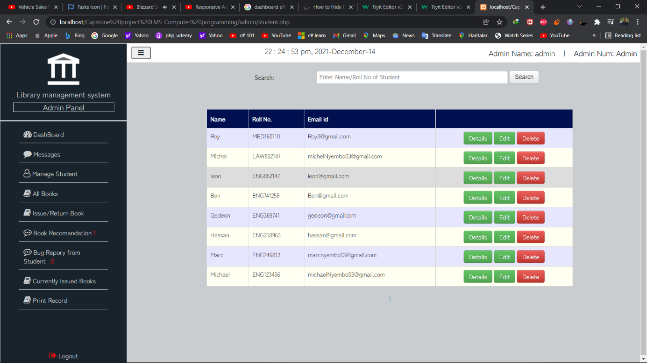

##### **3.1.3.2.8Edit student details page**

This page displays the student details

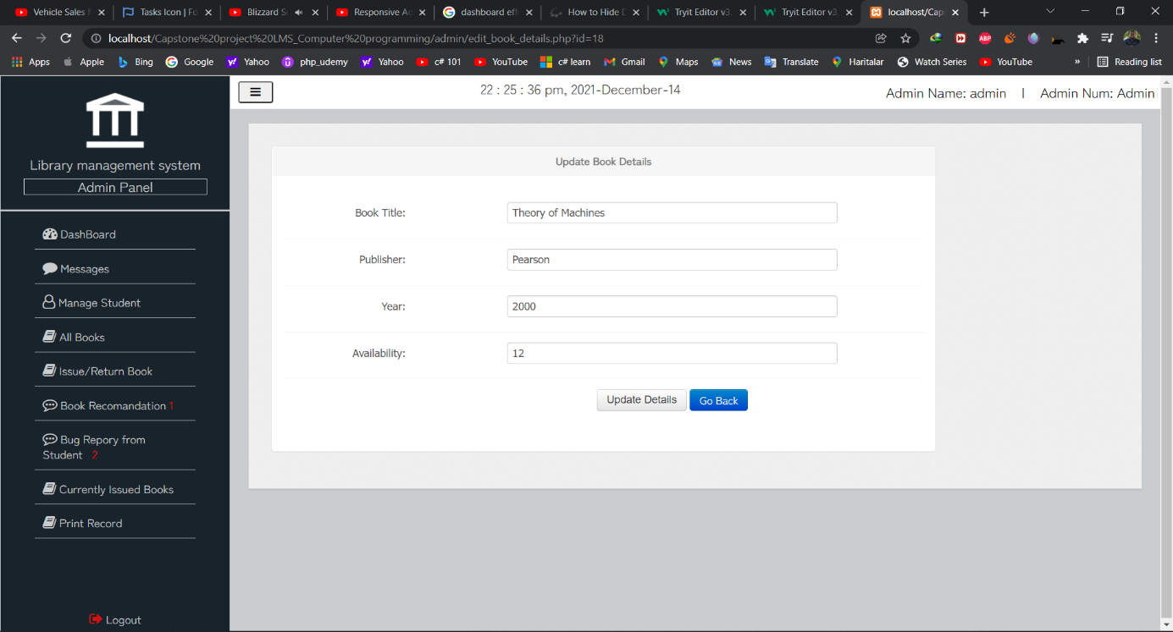

##### **Student details page**

This page displays the student details

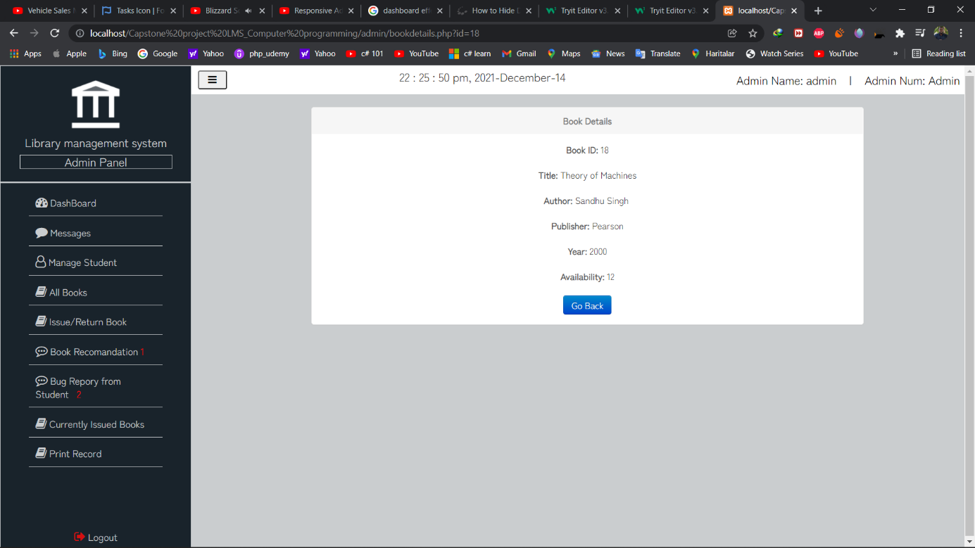

##### **3.1.3.2.9Book navigation Request page**

This page contains navigations to issue, return, and renewal request page

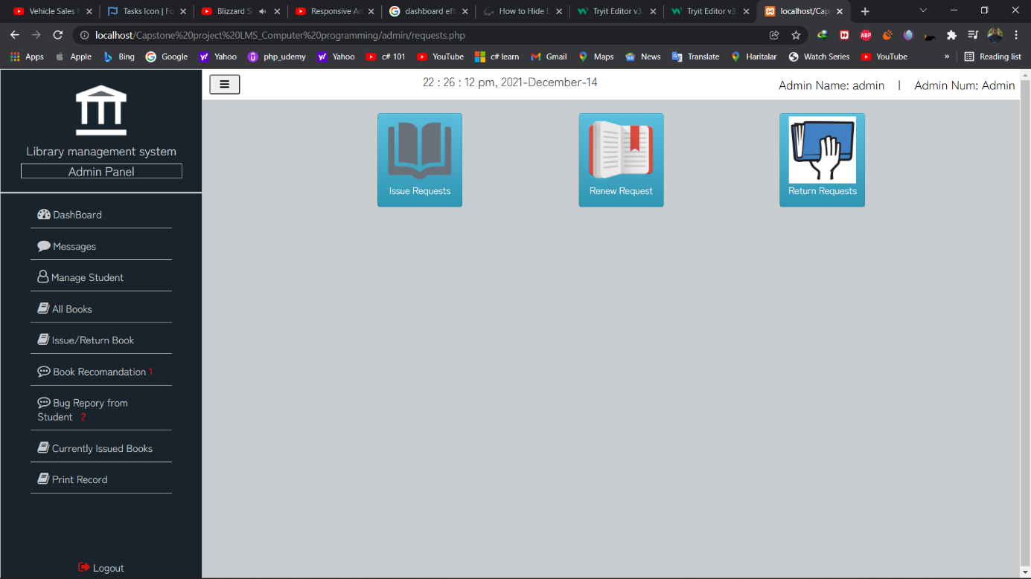

##### **3.1.3.2.10Request page**

This is the issue page issue request page where the admin receives request pages from deciding on accepting or rejecting them

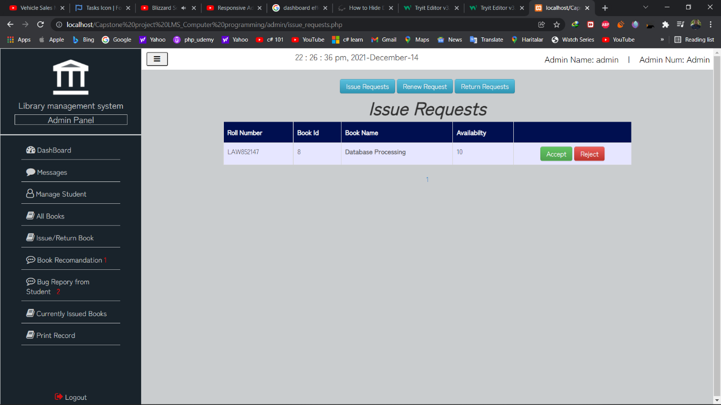

##### **3.1.3.2.11Renewal request page**

This is the issue renewal page where the admin receives request pages from students and accepts them because the system allows only one renewal

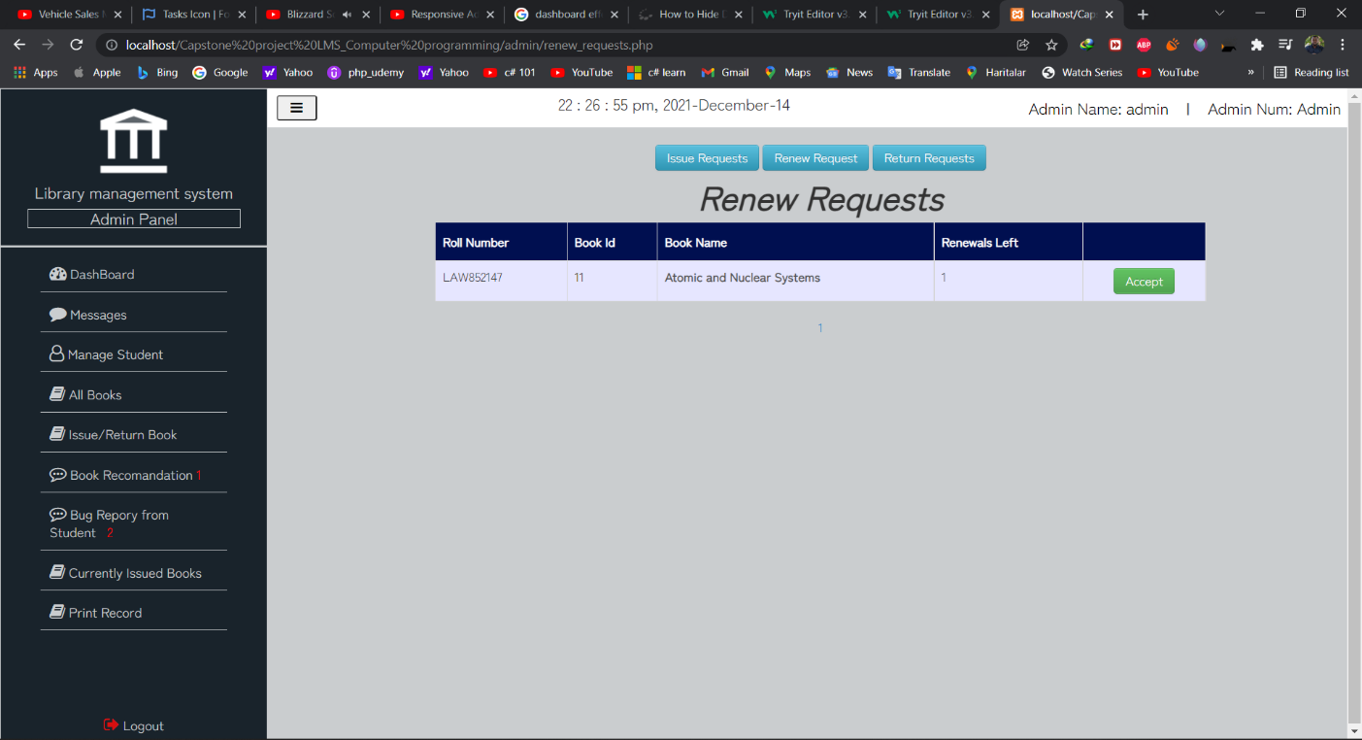

##### **3.1.3.2.12Return request page**

This is the return book page where the admin receives request pages from students and accepts them because the book is returned

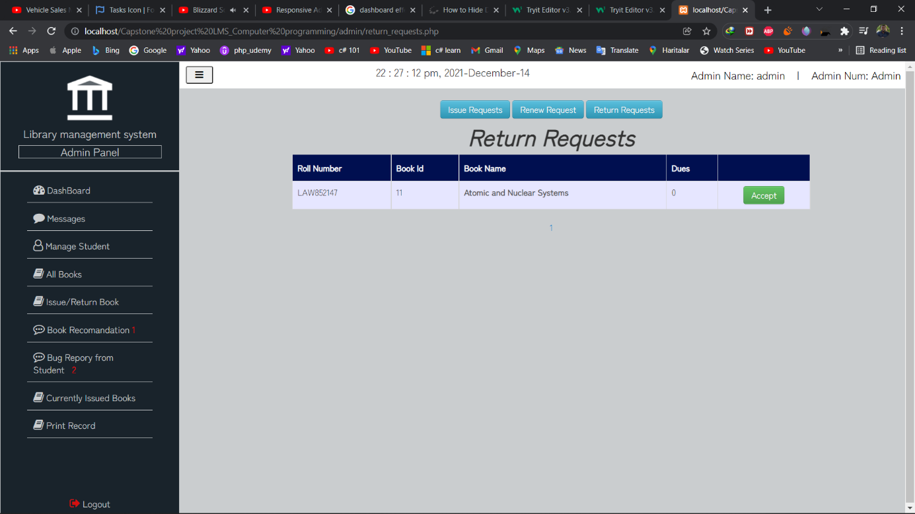

##### **3.1.3.2.13Book Recommendation page**

This is the book recommendation page where the admin receives book recommendations from student decide if he can add it or delete the recommendation

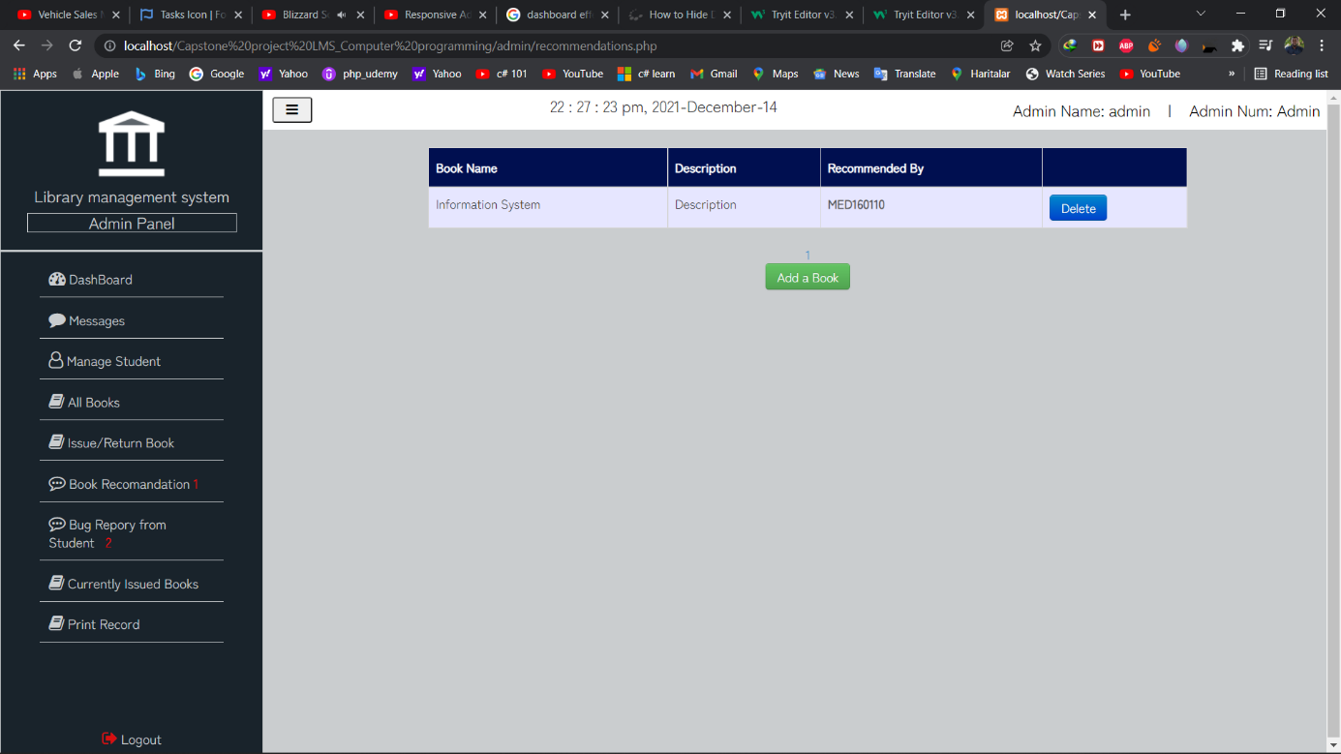

##### **3.1.3.2.14Bug Report page**

This is where the admin receives bug reports from student

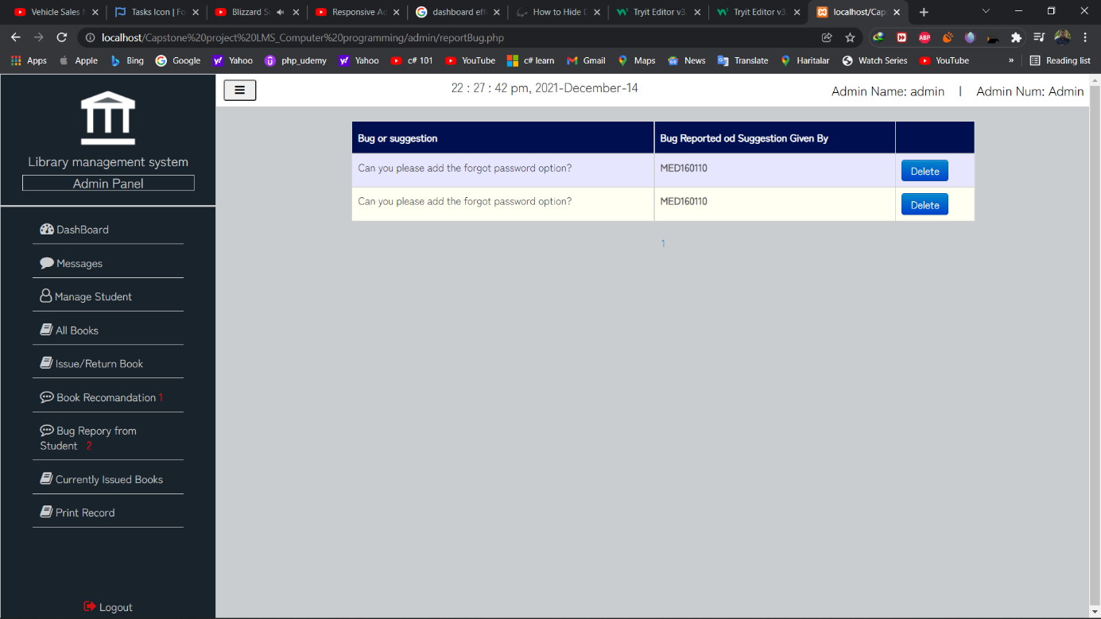

##### **3.1.3.2.15Current issued Book page**

This is the current book issue page where the admin can see the list of all the issued books with the issue date, due date, and the number of overdue dates

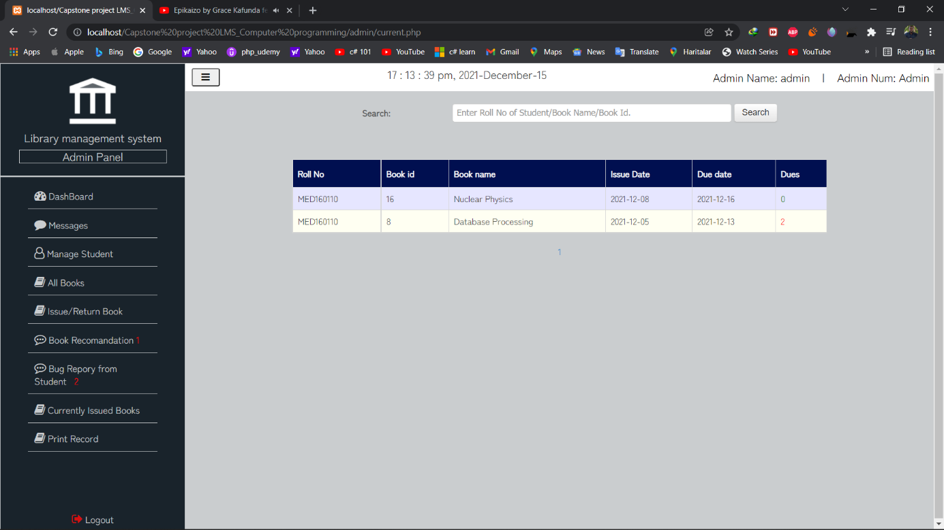

##### **3.1.3.2.16Record page**

This is where the admin can see all the library system record of the books and print it.

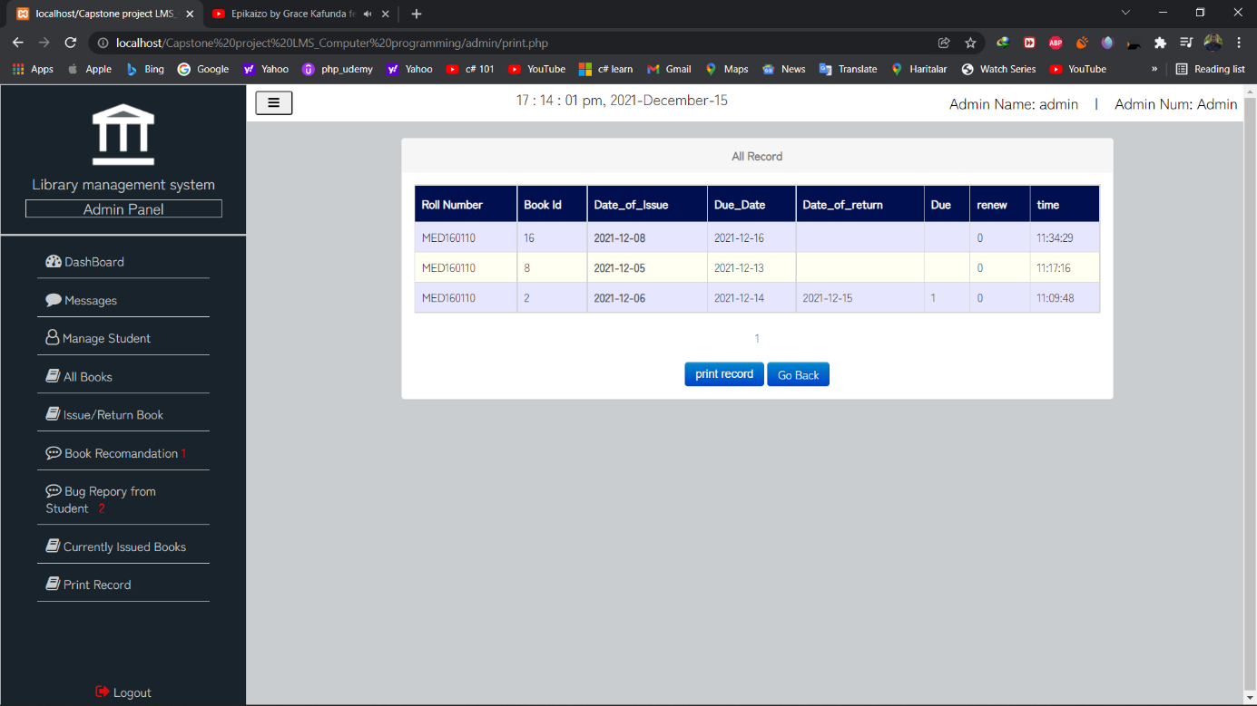

##### **3.1.3.2.17Print result**

This is the print page

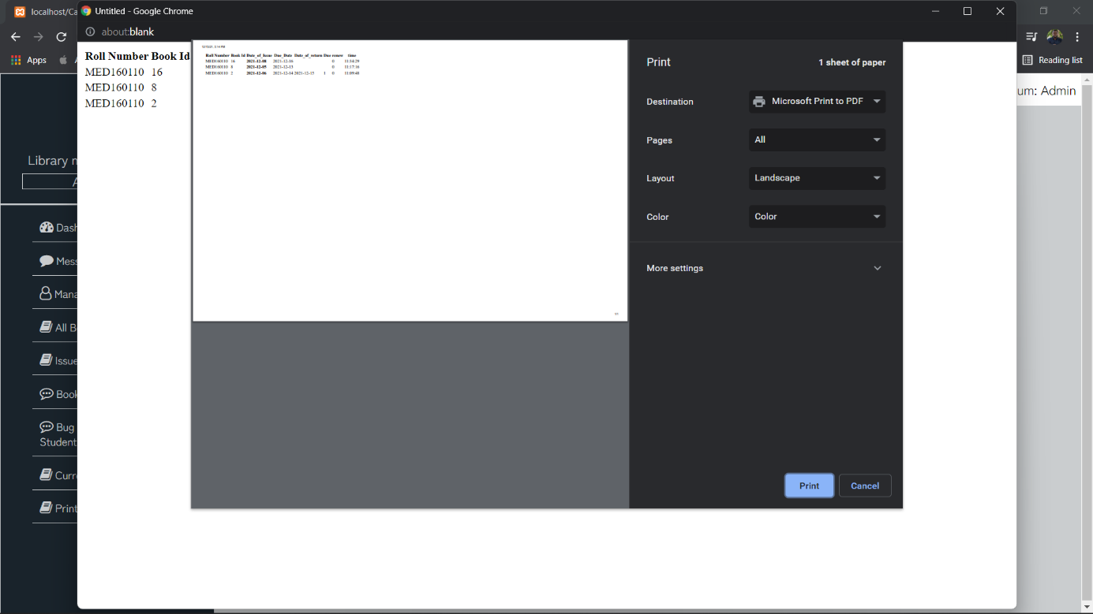

#### **3.1.3.3 STUDENT PANEL**

##### **3.1.3.3.1 Dashboard**

On this page, the student can see the number of Currently issued book

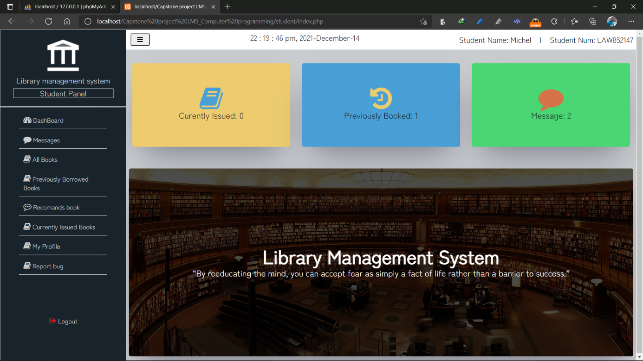

##### **3.1.3.3.2 Message page**

On this page, the student is receiving messages from the admin and confirmation messages from the system

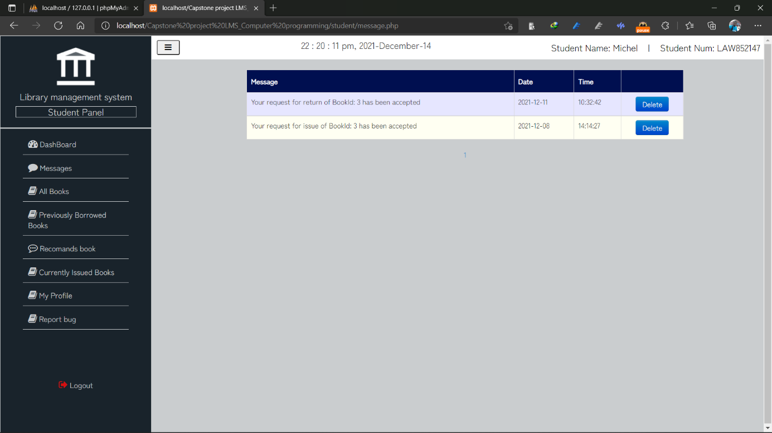

##### **3.1.3.3.3 Book page**

On this page, all the books are listed.

The student after finding the book in the library has to log in on the student panel from one of the pc in the library, get on the book page search the book by its id or title then read the details if he wants to and click on the issue button to send the request to the admin and then go the admin in person to notify him that a request has been already sent

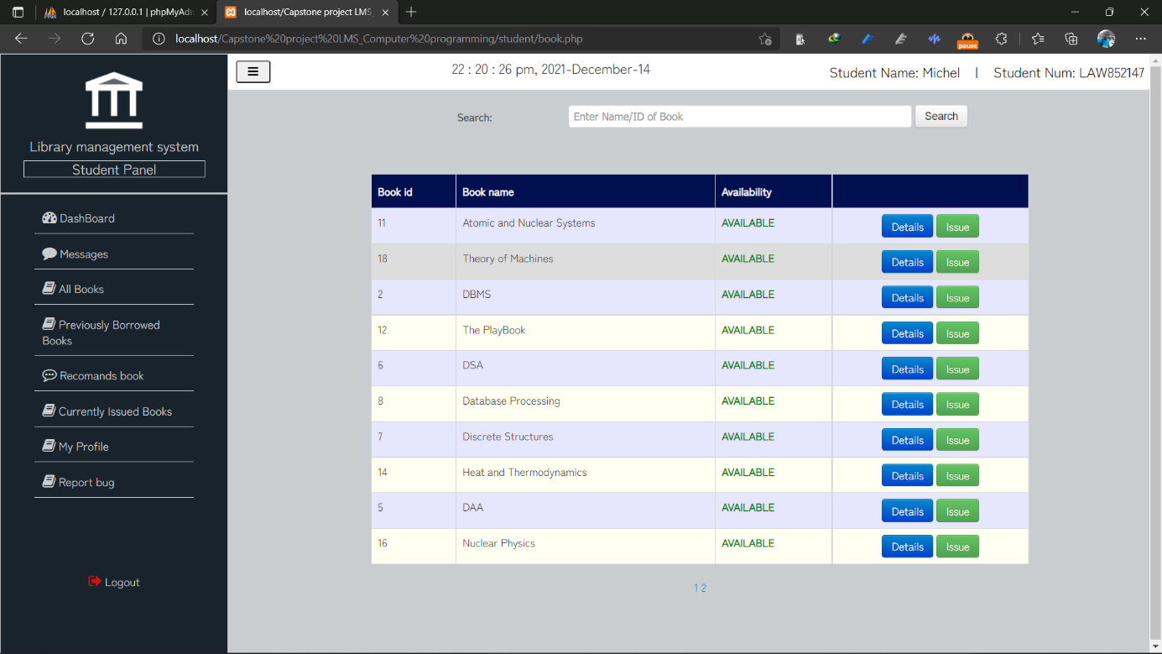

##### **3.1.3.3.4 Search book result page**

This page displays searched book

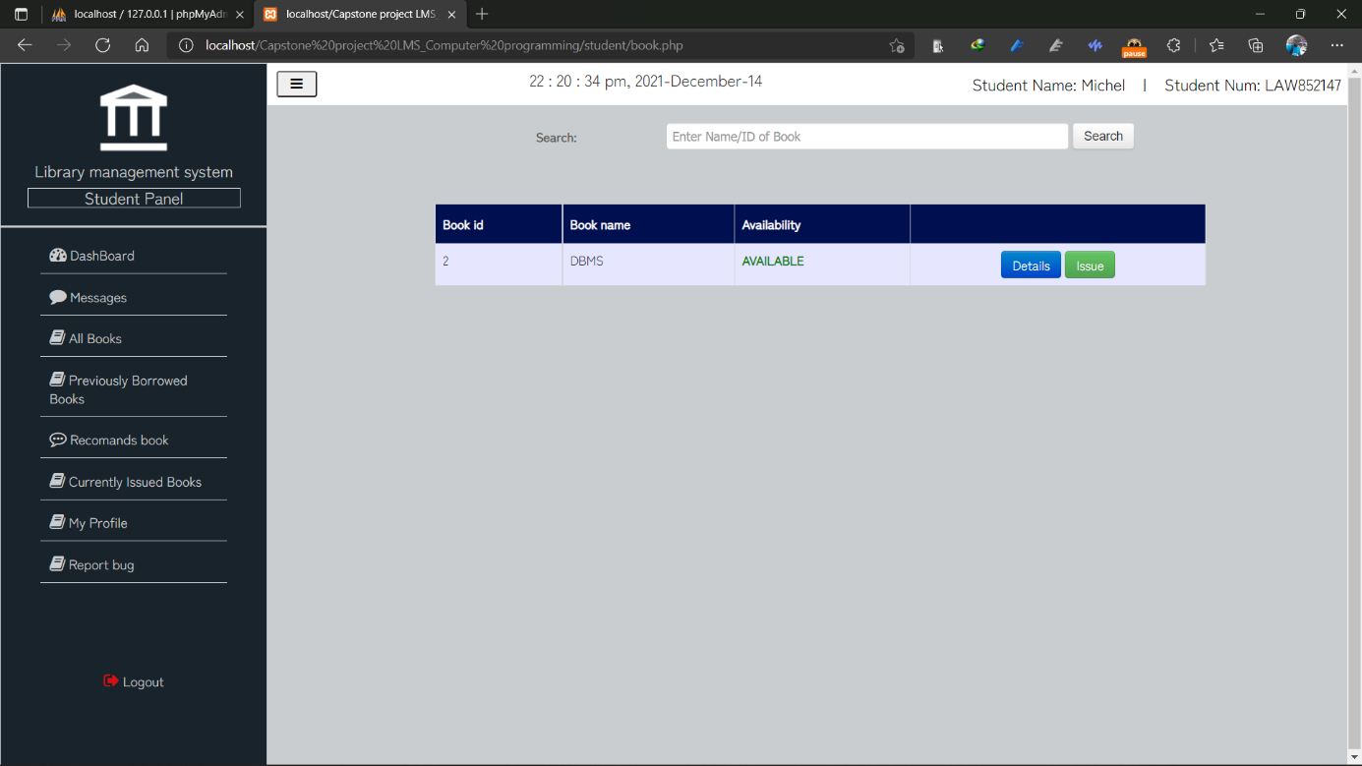

##### **3.1.3.3.5 Book details page**

This page displays the book details

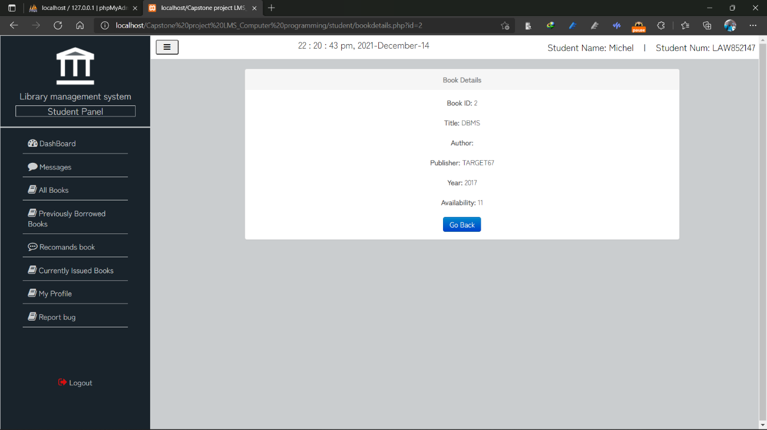

##### **3.1.3.3.6 History page**

On this page, all the previously issued books are displayed

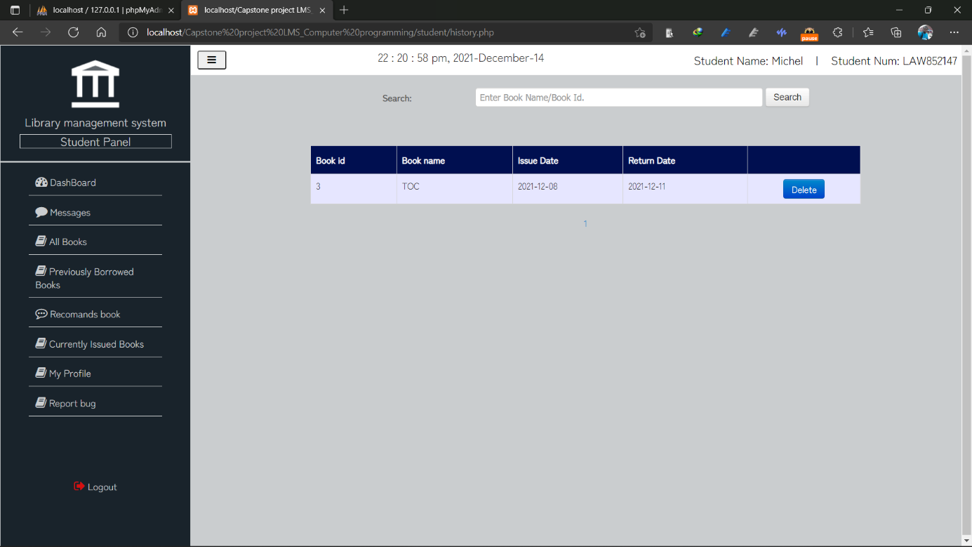

##### **3.1.3.3.7 Book Recommendation**

On this page, the student can recommend a book to the library

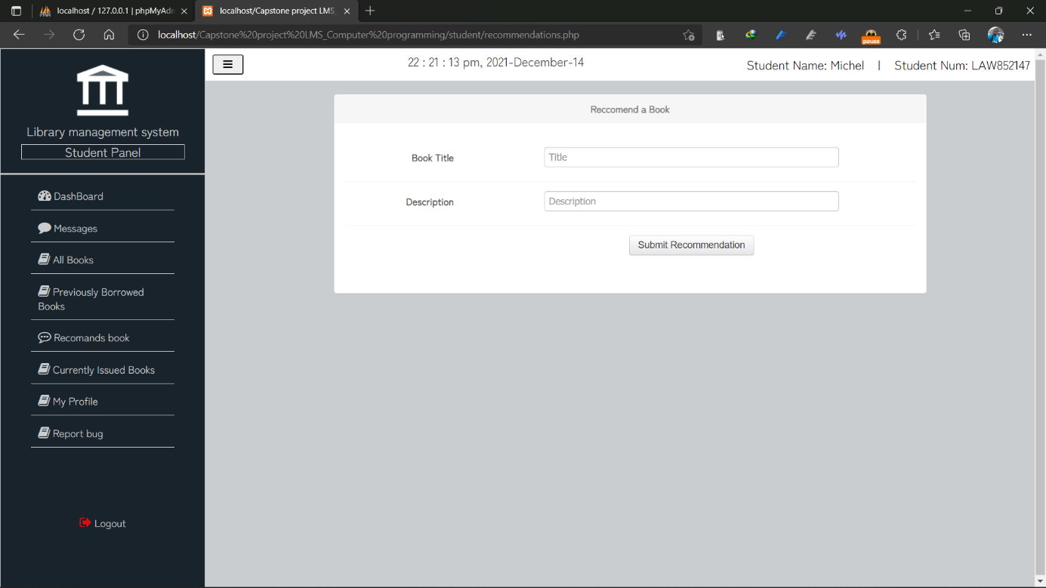

##### **3.1.3.3.8 Current Issued book page**

On this page, the student can see his current issued book and he can decide either to renew the or to return the book when the due date arrives

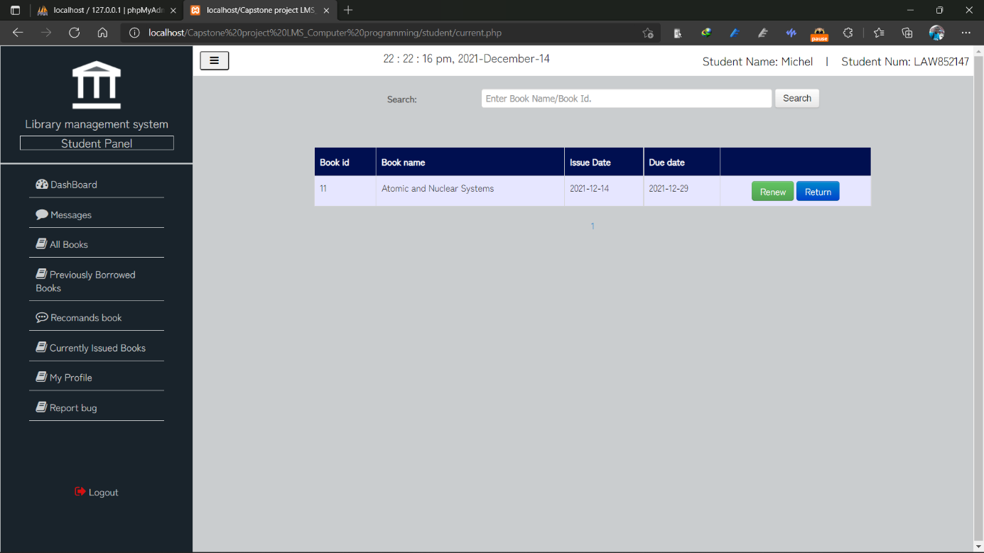

##### **3.1.3.3.9 Profile page**

On this page, the student can see his details by clicking on the detail button and editing his details by clicking on the edit button

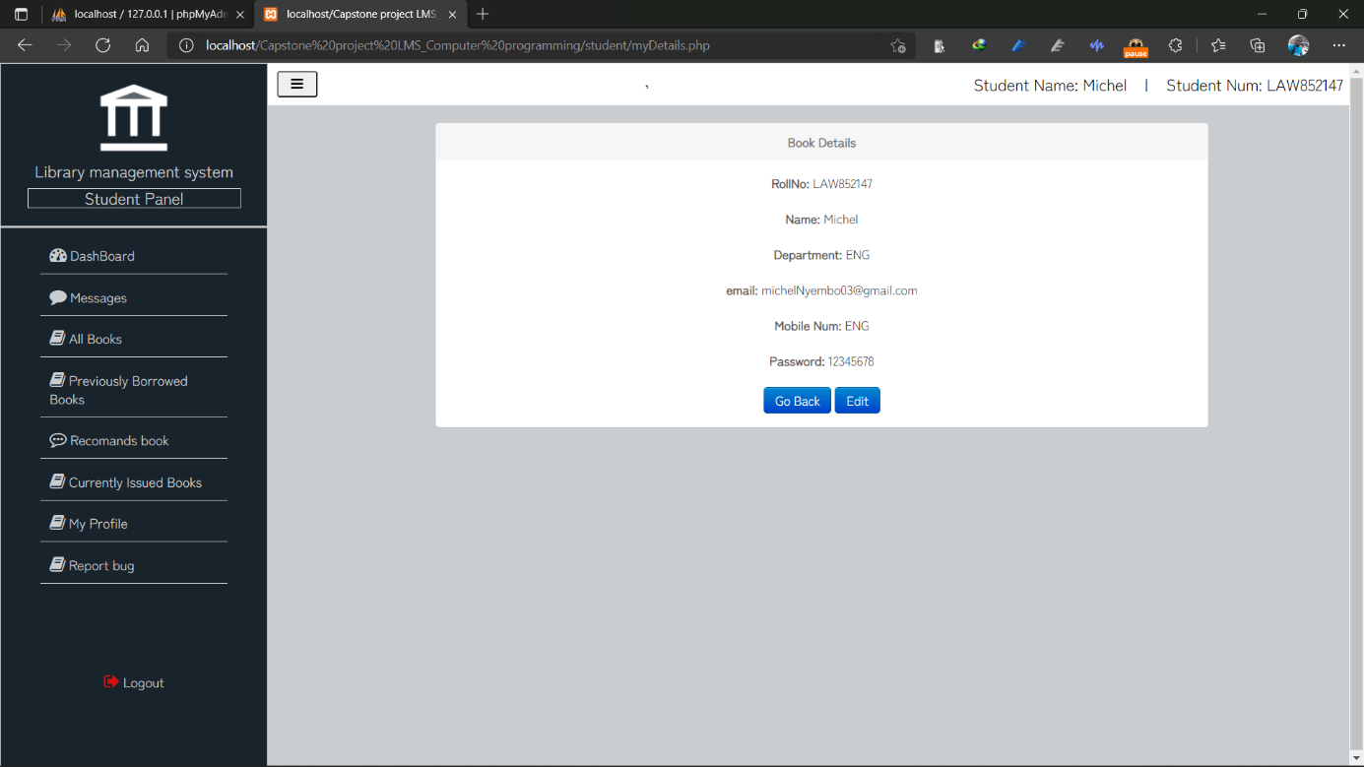

##### **3.1.3.3.10** Student edit profile page

This is the student edit page

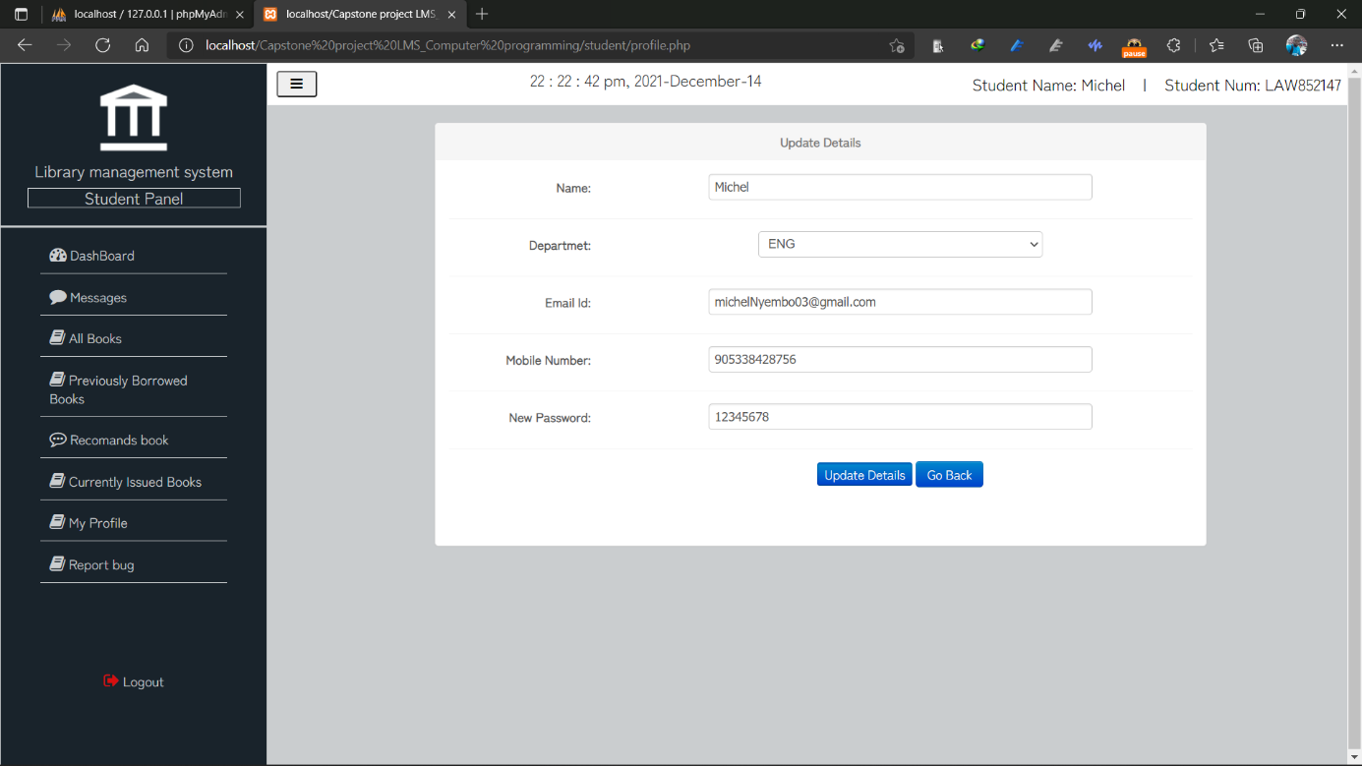

##### **3.1.3.3.11 Report bug and suggestion page**

On this page, the student can report a bug or suggest the system

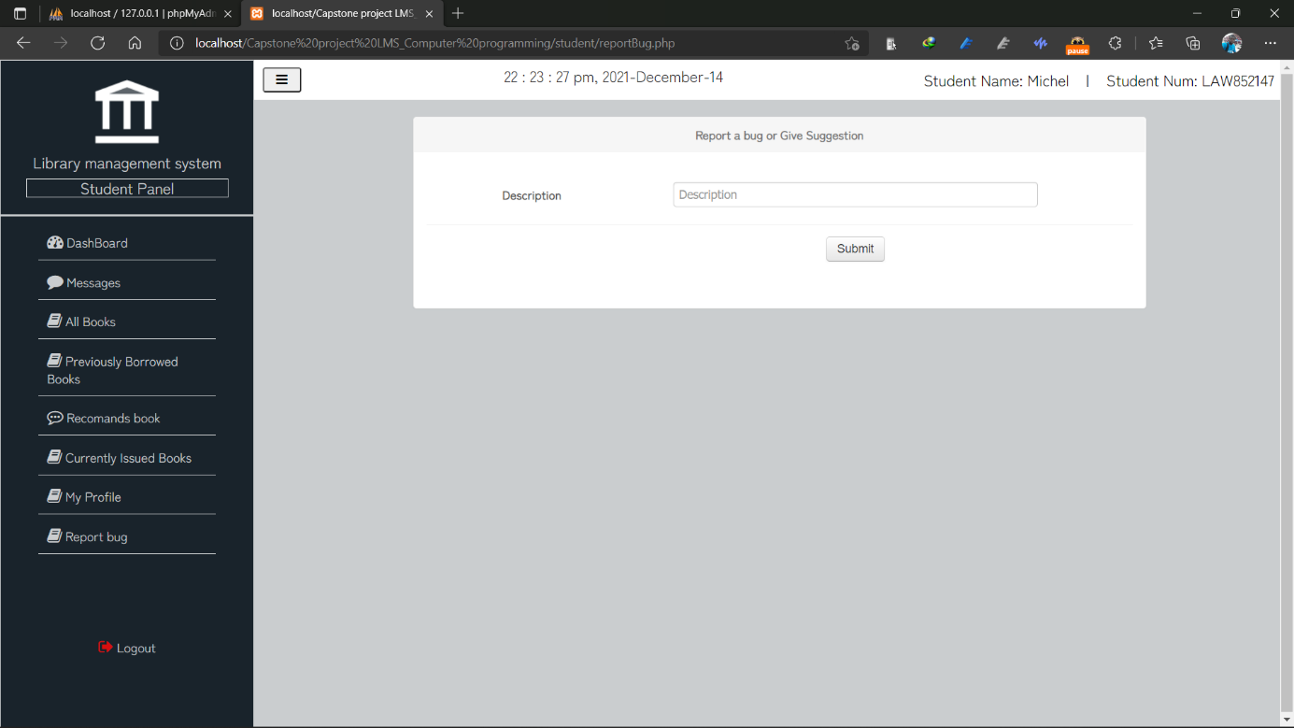

# **CHAPTER 4**

## **4.1 CONCLUSION**

This web application provides a computerized version of the library management system that will help both students and library employees. It makes the entire process online, allowing students to look for books, staff to manage transactions requests from students, and admin to print a record of all book transactions. It also offers a student login feature, which allows students to log in and see the status of books that have been issued, as well as request books or make suggestions.

This web application has future potential, such as instant database updates instead of refreshing the website every time, and online book reading.

# **REFERENCES**

MDN WEB DOCS (July 29, 2021).

What is JavaScript? <https://developer.mozilla.org/en-US/docs/Web/JavaScript>

Lauren Stewart (July 22, 2021).

FRONT END DEV VS BACK END DEV. <https://www.coursereport.com/blog/front-end-development-vs-back-end-development-where-to-start>

PHPMYADMIN (2003-2021).

Bringing MySQL to Web. <https://www.phpmyadmin.net/>

PHP (2001-2021).

What is PHP? <https://www.php.net/manual/en/intro-whatis.php>

W3SCHOOL (1999-2021).

PHP Tutorial. https://www.w3schools.com/php/default.asp